# 1916-2016 Centenary

Volume 1, Issue 1 May 2015

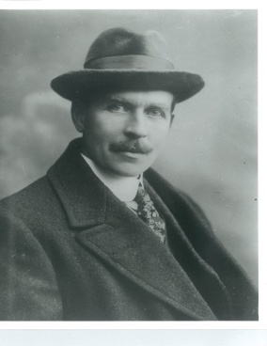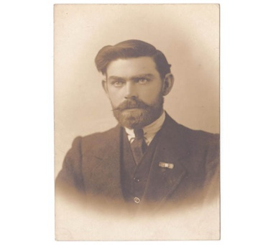

1916-2016 Lynch Commemoration News

N e w s l e t t e r

Easter Sunday Invites 2

New TG4 Documentary 2

The Forgotten Irish Patriot 3

Who was…Judge Cohalan? 3

Friends & Family attending 3

Diary Dates for 2016 3

Did you know? 4

1916 Web Site links 4

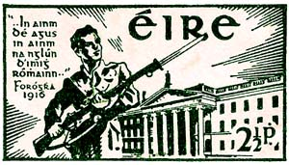

[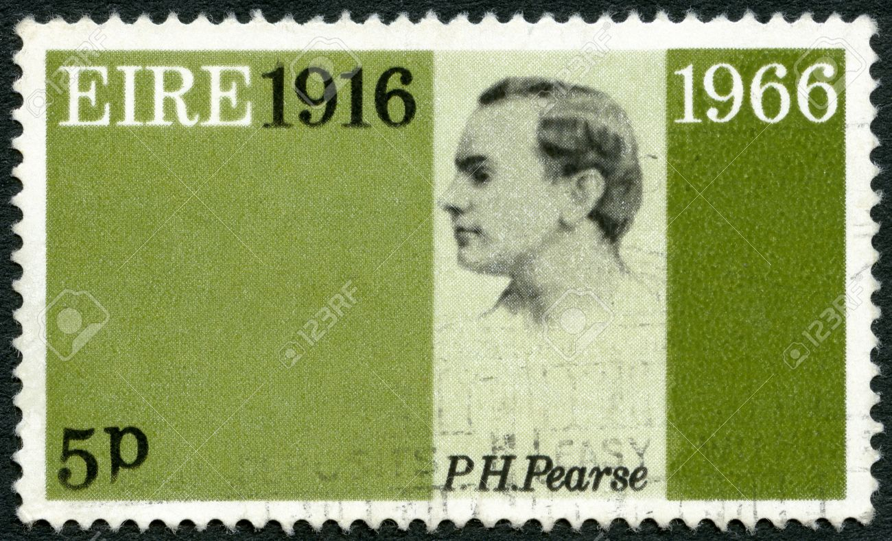](http://www.google.ie/url?sa=i&source=images&cd=&cad=rja&uact=8&ved=0CAgQjRw&url=http://www.123rf.com/photo_16896664_ireland-eire--circa-1966-a-stamp-printed-in-ireland-shows-patrick-henry-pearse-1879-1916--50th-anniv.html&ei=J2A2VdKmI6ip7Ab-3wE&psig=AFQjCNGbx8vFLsUiZJRA9oFHpmcyuAS30A&ust=1429713319659753)

[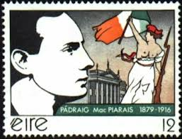](http://www.google.ie/url?sa=i&rct=j&q=&esrc=s&frm=1&source=images&cd=&cad=rja&uact=8&ved=0CAcQjRw&url=http://www.iiofpitt.org/UserFiles/File/Common%20Ground%20April%202011/Common%20Ground%20April.htm&ei=n142VczlJu6t7AbojICoAw&psig=AFQjCNFyA9IUnIJM-6LWxAaNKrmX2VHmvA&ust=1429712796943331)

Pictured - Top: Diarmuid c.1918 and Michael c.1916 on release from Frongoch.

Middle: Republic of Ireland stamps marking the 1916 Rising – 1941, 1966 & 1991



**Newsletter Contact**

*Ruairi Lynch*

*086-8396428*

*ruairi_lynch@hotmail.com*

Welcome to the first edition of the 2016 Newsletter – sent to descendants, extended family & friends of Diarmuid and Michael Lynch.

As the countdown to the Centenary commemoration has begun, rather than email various updates and news to all and sundry, you can now get all the news for the Lynch Centenary commemoration in one place – this Newsletter - monthly to your email address or by mail if you prefer.

Hopefully it will keep you up to date with what’s taking place, events, dates, locations and how you too can join in the national commemorations.

Do you have news, views, articles or comments to make? Get in touch.

Inside this issue:

### Newsletter 1st Edition

## **Countdown to 2016 ....**

**Comment**

With less than a year before the 1916 Centenary Commemoration begins, you can’t help but notice the inescapable issues of the moment – legacy and commemoration.

However, it does seem to many that the Irish Government has developed collective amnesia, a phobia of sorts when it comes to commemorating the Easter Rising.

Our current government seem to be more content that Irish people look to St Patrick’s Day, pints of Guinness, plastic paddy parodies and shamrocks when it comes to identifying with their nationality and Irishness.

You may have noticed the awful video produced late last year and featured on the official government website ireland.ie to mark the centenary of the 1916 Easter Rising.

Apart from its blandness and looking like a promo for the Gathering Mark II it had one major failing — it didn’t actually mention the Rising.

It had Bono, Bob Geldof, the Queen and even Ian Paisley, but there was no sight nor sound of Pádraig Pearse, James Connolly or any of those who took part in 1916. The Government quickly noted the public ridicule and backlash as the video disappeared from the internet. However, it did leave a lasting impression that the Government is seemingly intent on celebrating 2016 without any actual reference to 1916.

Maybe it comes down to Civil War politics, a sense of triumphalism or that the Government simply does not want in any way to fan[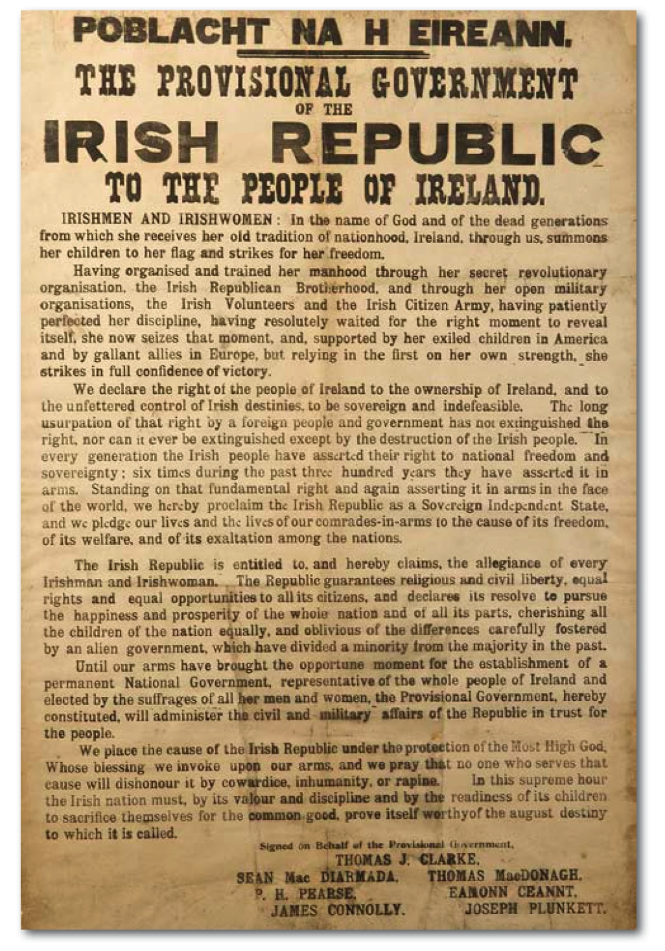](http://www.google.ie/url?sa=i&rct=j&q=&esrc=s&frm=1&source=images&cd=&cad=rja&uact=8&ved=0CAcQjRw&url=http://www.centenarymayo.ie/?page_id=1939&ei=YE4uVffeA5KOaJjGgYAG&bvm=bv.90790515,d.ZGU&psig=AFQjCNHhzr0gwiKzmI6fvUqpLPHnZei9Bg&ust=1429184456564544)

the flames of republicanism at a time when our relationship with the UK is stronger than ever, people are protesting on the streets and Sinn Fein is becoming a significant political power.

But perhaps the more the Government sidesteps the issue, the more it plays into the hands of those who want to politicise 2016, rather than celebrate it for the ideals put forward in the Proclamation and that would eventually lead to creating the country we live in today.

1916-2016 Commemoration Newsletter May 2015

Michael c. 1916 Frongoch Internment Camp, Wales.

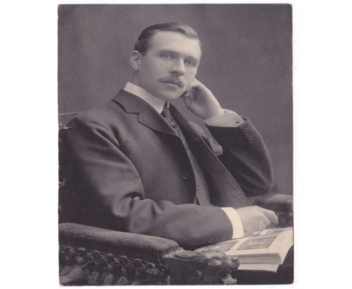



**Irish Government Commemoration Website:**

[www.Ireland.ie](http://www.Ireland.ie)

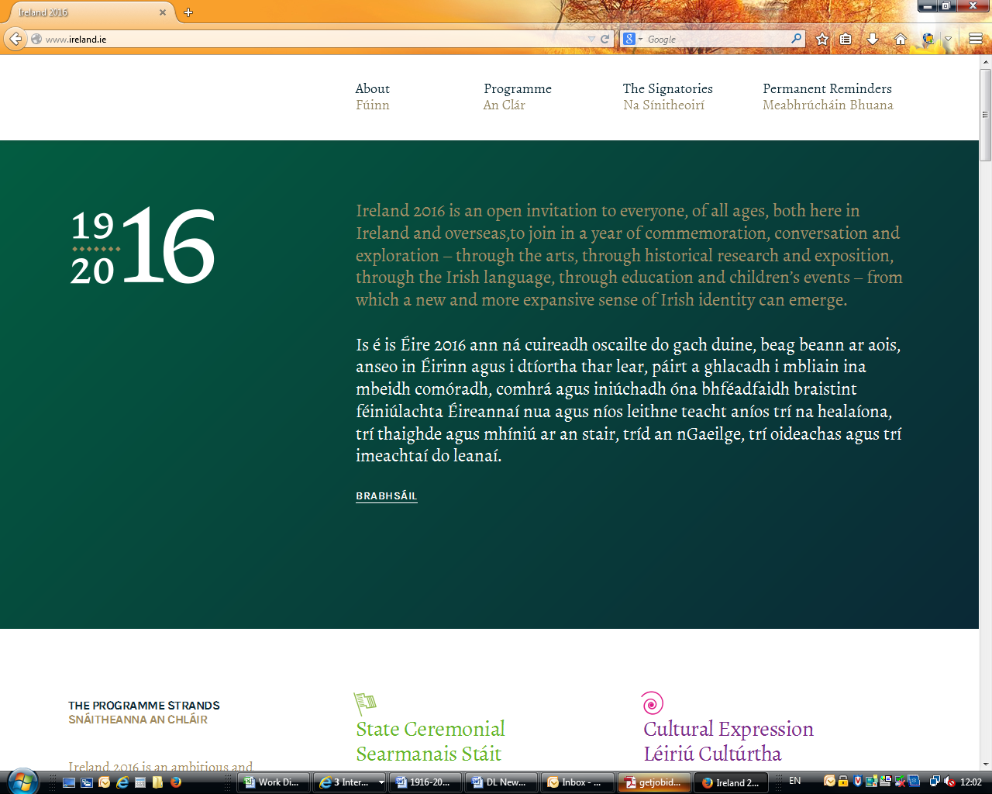

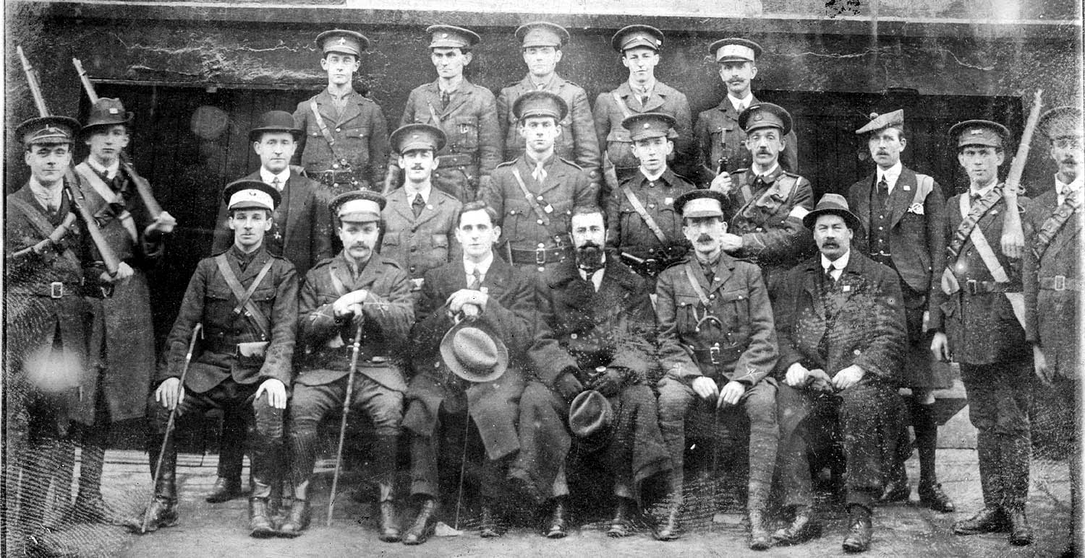

Cork Irish Volunteers Executive 1915. Diarmuid third from right.

A new documentary “Diarmuid Lynch - The Forgotten Man of 1916” is currently under production for TG4 by Director Ciara Hyland (below).



[www.ciarahyland.com](http://www.ciarahyland.com)

Ciara has spent several years working on feature films, commercials, TV series, documentaries and short films funded by, among others, Disney, BBC, RTE and the Irish Film Board. Her credits include Mystic Knights, The Ambassador, Ballykissangel, Sweeney Todd, Disco Pigs and Oliver Twist.

In 2008 she produced two short films, both of which were RTE Short Script Awards and one of which (Out of the Blue - directed by Michael Lavelle) went on to win several awards internationally including: Best International Short - London Independent Film Festival 2009, Best Cinematography - Rhodes Island Film Festival 2009 and Best Short Comedy – Toronto Independent Film Festival 2009.

Since 2009 Ciara has worked freelance in research and production on documentaries and long running series for RTE and TG4.

Her credits include the traditional music series "Geantraí" for TG4, the "Fleadh Cheoil" series for RTE and "Spillane an FánaÍ" with singer/ songwriter John Spillane for TG4.

It was while filming an episode of "Spillane an FánaÍ" in Gorey, Co. Wexford that Dolores met Ciara and over ‘*a Hennessy or two’* told her more of Diarmuid’s life story. This in turn led to the documentary proposal by Ciara and commissioning by TG4.

Ciara has already met with Mary & Eileen McGough in Granig and her team will be filming there at the end of May.

The documentary is scheduled for broadcast on TG4 later in 2016.

[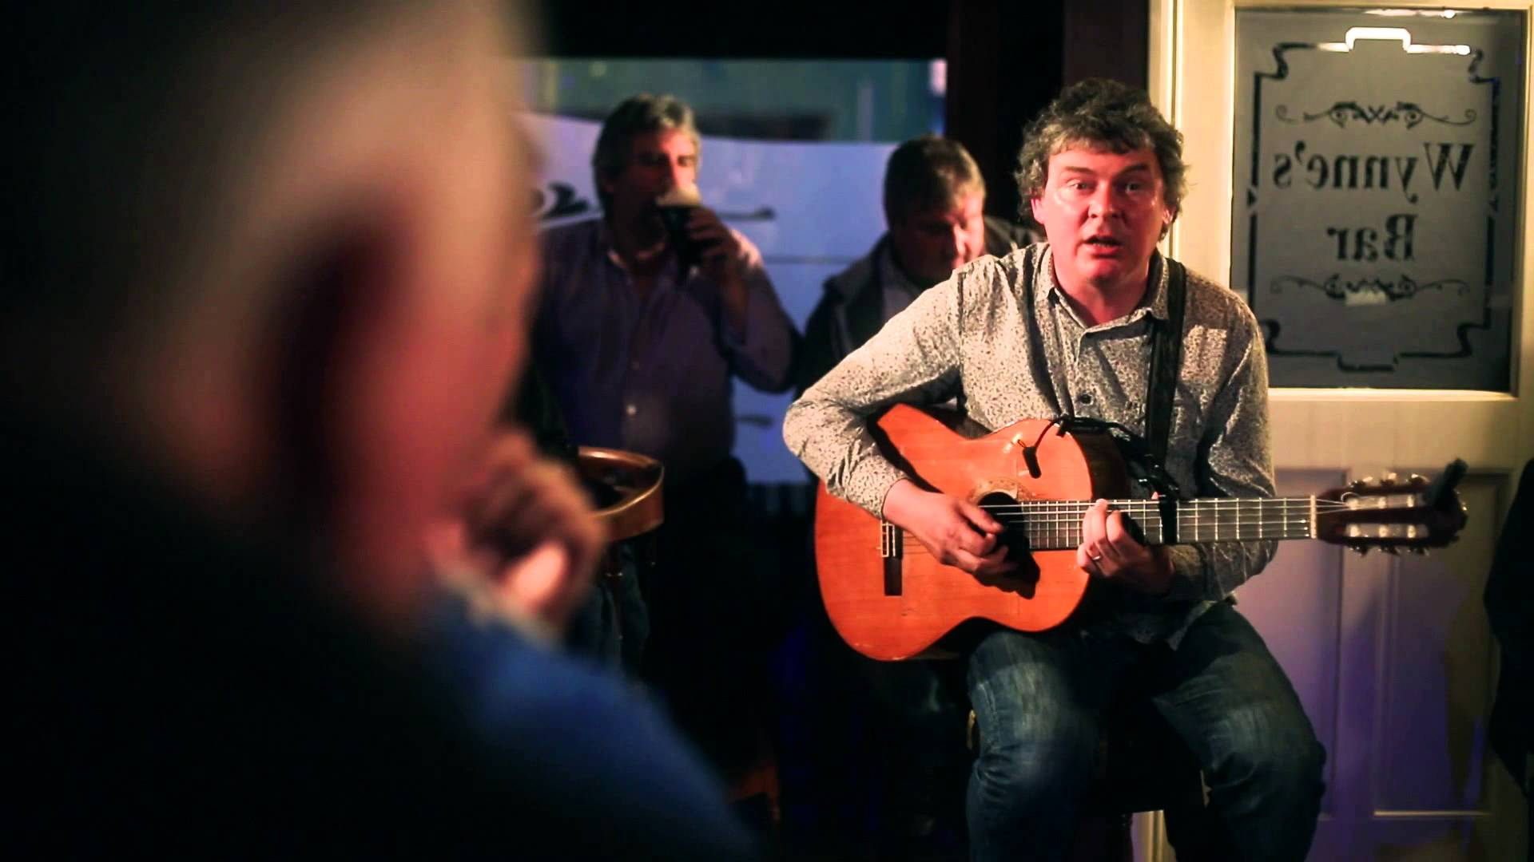](http://www.google.ie/url?sa=i&rct=j&q=&esrc=s&frm=1&source=images&cd=&cad=rja&uact=8&ved=0CAcQjRw&url=http://www.youtube.com/watch?v=R90DjvhSE4w&ei=VtA4VdXNGuOv7Aa734CYBg&bvm=bv.91427555,d.ZGU&psig=AFQjCNHdSnhYyirrMjbCR94ruW24lHxKug&ust=1429873072313957)

The Spillane an Fanai series is currently not available on the TG4 viewer but the series is available to buy online

If you would like a DVD copy of Dolores’ meeting with John Spillane in Gorey – let me know and I’ll mail you one. Sorry, DVD playable in Ireland & UK only.

Diarmuid c.1903 A New York Studio photograph while President of the Philo-Celtic League.

[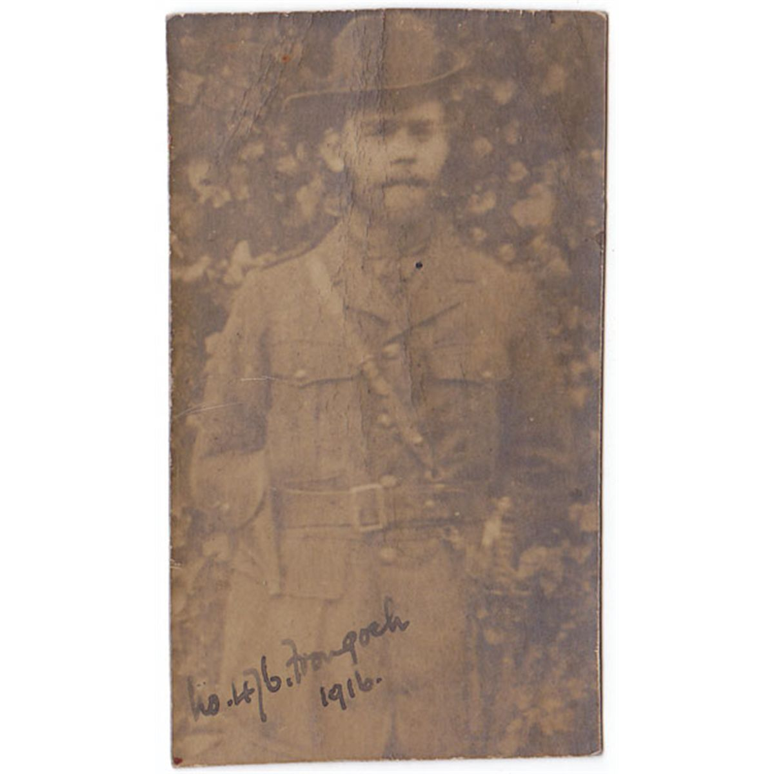](http://www.google.ie/url?sa=i&rct=j&q=&esrc=s&frm=1&source=images&cd=&cad=rja&uact=8&ved=0CAcQjRw&url=http://www.icollector.com/1916-Diarmuid-and-Michael-Lynch-photographs_i11187851&ei=LXQuVaTNINfbavyXgMgI&bvm=bv.90790515,d.ZGU&psig=AFQjCNH3TK9Lgs3b8QCxIPvIfbejwsgtIg&ust=1429194140818069)

### Easter Sunday 2016 Invitations

Page 2

Thanks to all for returning your expressions of interest for the Easter Sunday 2016 Commemoration.

These will be sent to the Department of Defence who will be back in touch with you in early 2016.

As you will have read in the circular attached to the application, these are just expressions of interest and are not a guarantee of attendance or a seat at the Easter Sunday event. However, all are invited to the Farmleigh House event on Easter Saturday evening.

The Easter Sunday Commemoration is scheduled to begin at 12 noon, March 27th 2016 at the GPO and will include:

* A Military ceremony which will include a reading of the Proclamation by an Army Officer.
* The laying of a wreath by the President on behalf of the Irish people.
* A minute silence following by the Last Post and the raising of the National Flag.
* Reveille and the National Anthem.
* A Parade that will run from Dublin Castle, to O’Connell Street, passing the GPO and finishing at Parnell Square.
* An Air Corps Fly Past.

### New TG4 Documentary on Diarmuid

1916-2016 Commemoration Newsletter May 2015

person holding globe

Family members & friends attending Easter 2016:

Daly, Daire

Daly, Saoirse

Daly, Ruairi

Daly, Diarmuid

Daly, Aja

Daly, Kale

Daly, Duibhne

Duggan, Brid

Lynch, Dolores

Lynch, Mary

Lynch, Ruairi

Anglim, Helen

Ryan-Lynch, Rebecca

Ryan-Lynch, Cianna

Ryan-Lynch, David

Lynch, Cormac (US)

Lynch, Gaye (US)

Lynch, Diarmuid

Lynch, Christine

Lynch, Robyn

Lynch, Diarmuid

Lynch, Hugh

McGough, Eileen

Collins, Mylie

Murphy, Nora

Murphy, Mark & Eilis

Scott, Dolores & Partner

Scott, Niamh & Partner (UK)

Scott, Michael & Partner (UK)

Cohalan, Judge Peter Fox & Guest (US)

Plus others to confirm.

Missed anyone? Get in touch!

Dublin’s hotels will be heavily booked during Easter 2016, so it’s suggested you make your reservations quickly.

Many of us are staying at the Hilton Double Trees, Dublin 4 (former Burlington) so do come and join with family & friends.

**Daniel Florence Cohalan** (1867 -1946) was an American lawyer, jurist and politician from [New York](http://en.wikipedia.org/wiki/New_York).

He was a close friend and associate of Diarmuid’s during his life in the US. The Judge was also an associate of the Irish American revolutionary leader [John Devoy](http://en.wikipedia.org/wiki/John_Devoy) and was influential in many Irish-American societies including [Clan na Gael](http://en.wikipedia.org/wiki/Clan_na_Gael) in the early part of the century.

Judge Cohalan was involved with the financing and planning of the [Easter Rising](http://en.wikipedia.org/wiki/Easter_Rising) in Dublin and was instrumental in sending [Roger Casement](http://en.wikipedia.org/wiki/Roger_Casement) to Germany in 1914. He was Chairman of the [Irish Race Convention](http://en.wikipedia.org/wiki/Irish_Race_Convention) held in Philadelphia ( 1919) and active in the [Friends of Irish Freedom](http://en.wikipedia.org/wiki/Friends_of_Irish_Freedom) (1916–1934).

Cohalan strongly opposed President  [Wilson](http://en.wikipedia.org/wiki/Woodrow_Wilson)'s proposals for the [League of Nations](http://en.wikipedia.org/wiki/League_of_Nations), on the basis that the [Irish Republic](http://en.wikipedia.org/wiki/Irish_Republic) had been denied a policy of [self-determination](http://en.wikipedia.org/wiki/Self-determination) at the [Paris Peace Conference](http://en.wikipedia.org/wiki/Paris_Peace_Conference,_1919) in 1919. Cohalan, along with Devoy and Diarmuid disagreed with both [Éamon de Valera](http://en.wikipedia.org/wiki/%C3%89amon_de_Valera) and Irish-American leader [Joseph McGarrity](http://en.wikipedia.org/wiki/Joseph_McGarrity) in late 1919 on Irish-American political direction.

Judge Cohalan’s grand-nephew Peter Fox Cohalan has been in touch and plans to attend the commemoration next year travelling from his New York home and representing the Cohalan family.

“...I was last here for the 50th Anniversary events in 1966 with my father, Justice John P Cohalan, Jr., a Justice of the New York State Supreme Court...” Peter is also a retired Justice of the New York State Supreme Court.

We look forward to meeting and welcoming Peter to Ireland – so make sure you meet up with him over the Easter weekend.

[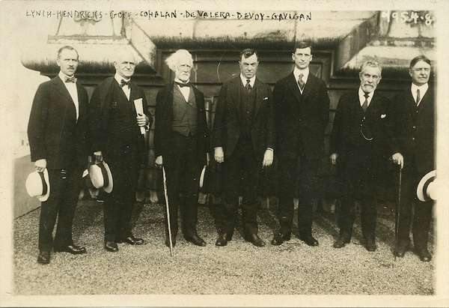](http://www.google.ie/url?sa=i&source=images&cd=&cad=rja&uact=8&ved=0CAgQjRw&url=http://www.jamesadam.ie/53833/DE-VALERA-Eamon-A-rare-photograph-of-Eamon-De-Valera-in-America-Included-in-the-photo-are-Diarmuid-Lynch-Justice-Hendricks-J-W-Goff-Judge-Daniel-Cohalan-De-Valera-John-Devoy-and-Justice-Gavigan?ipp=All&keyword=&view=lot_detail&ei=xD02Vc-TM-aC7gbV14Eg&psig=AFQjCNH9ja9ASsGvfdALv_eWoNutAKE7Cw&ust=1429704516919491)

1920 photo (L-R): Diarmuid Lynch, Justice Hendricks,, J.W. Goff, Judge Daniel Cohalan, De Valera, John Devoy and Justice Gavigan. Taken on the roof of the old Waldorf Astoria Hotel NY, now the site of The Empire State Building.

### Who was…. Judge Daniel F. Cohalan?

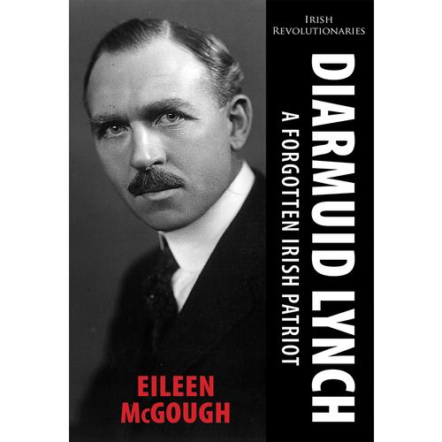

Eileen’s book on Diarmuid continues to be a source of interest and pride within the extended family but it’s also generating strong interest among today’s historians who have recently begun referencing her work.

History Ireland Magazine in the March/April 2015 issue has an article by Michael Doorley with numerous references to Diarmuid and Eileen’s book.

Diarmaid Ferriter (Professor of History UCD) has also quoted Eileen’s book and made reference to it in his latest hardback history: *'A Nation and Not a Rabble: The Irish Revolution 1913-1923.*

A recent reviewer of Prof. Ferriter’s book struck a chord with us in relation to Diarmuid and Michael when he observed that in the years after the events of 1916-1923: *“What is perhaps most striking is the speed with which the living memory of the intensely dramatic events (of 1916 & the War of Independence) faded. Distinguished veterans faced interrogation by people who seem to have had no idea who they were and little sense of what they had done.’*

Eileen’s book is currently available at all good bookshops nationwide or direct from Mercier Press

<http://www.mercierpress.ie/irish-books/diarmuid_lynch_a_forgotten_irish_patriot/>

'A valuable contribution to Irish historiography' - Irish Examiner

'A carefully researched and well-written book about a man whose part in the independence struggle deserves to be better known and more widely acknowledged' - Irish Echo

'This new book...will go a long way to rightly reinstate him as being one of the most influential figures in Irish early 20th century nationalism' - Leinster Leader

Xxx

X

X

Xx

X

Xx

X

X

X

X

X

X

X

X

.

### A Forgotten Irish Patriot....

Page 3

1916-2016 Commemoration Newsletter May 2015

[](http://www.google.ie/imgres?imgurl=http://icons.iconarchive.com/icons/marcus-roberto/google-play/512/Google-Calendar-icon.png&imgrefurl=http://www.iconarchive.com/show/google-play-icons-by-marcus-roberto/Google-Calendar-icon.html&h=512&w=512&tbnid=3wWE1QhCTYsfGM:&zoom=1&docid=5vCoYGns18XxuM&ei=y9Y4VZeoM6qt7AbKx4CwDw&tbm=isch&ved=0CFMQMygYMBg) Diary Dates 2015-2016

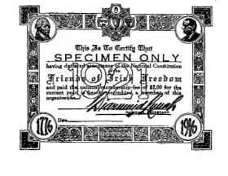

Did You Know?

The Friends of Irish Freedom was an Irish-American [Republican](http://en.wikipedia.org/wiki/Republican_Party_(Ireland)) organisation founded in 1916 and supported by many Irish-American organisations.

The Friends of Irish Freedom supported the [1916 Rising](http://en.wikipedia.org/wiki/Easter_Rising) and in the months following, raised $350,000 (equivalent of $8 million today) through the Irish Relief Fund to assist dependents of many who fought in the Rising.

In May 1918, the Friends of Irish Freedom organised the fourth Irish Race Convention during which [Diarmuid Lynch](http://en.wikipedia.org/wiki/Diarmuid_Lynch) became National Secretary holding the post until his return to Ireland in 1932.

By 1920, there was a Regular membership of 100,000 and 484 Associate Branches with an Associate membership of 175,000. The Friends of Irish Freedom was wound up in 1932 following extensive litigation concerning the funds raised for the Irish Republic which were claimed by de Valera, most of the funds were returned to the original donors.

Sample of a Friends of Irish Freedom membership card from 1920 signed by Diarmuid Lynch.

***March 26 - Easter Saturday***

* Garden of Rememberance., Dublin 1: Rememberance Ceremony.
* State Reception for 1916 participants relatives

***March 27 - Easter Sunday***

* State ceremonies at the GPO, Dublin marking the centenary of the Rising.
* State Reception for all guests invited to the State Cermony at the GPO.

**Would you like to contribute an article or comment to the Newsletter?**

**Get in touch and tell us.**

**ruairi_lynch@hotmail.com**

**voice-mail/text: 086-8396428**

**Next Edition:**

**late May 2015**

Decade of Centenaries <http://www.decadeofcentenaries.com/>

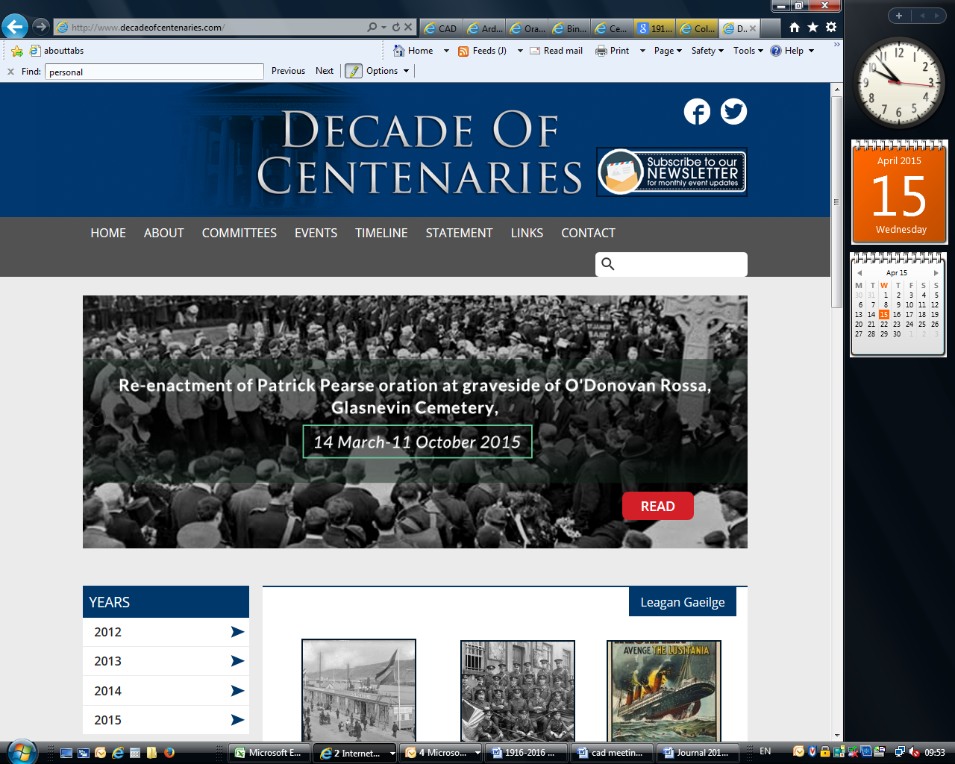

National Archives – Census 1901 & 1911 : <http://www.census.nationalarchives.ie/>

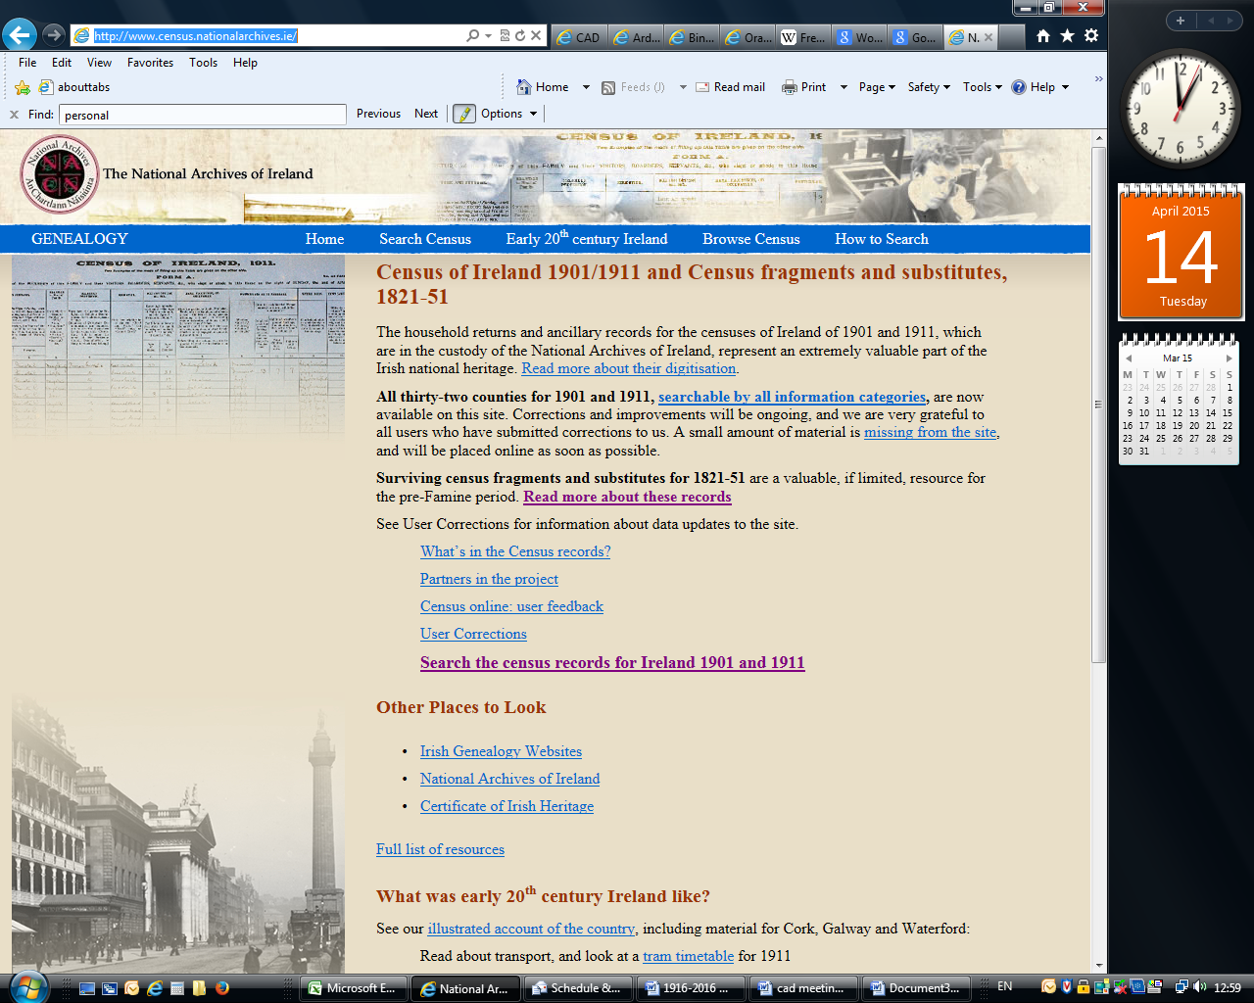

Irish Defence Forces Archives & Military Pensions: <http://www.militaryarchives.ie/en/home/>

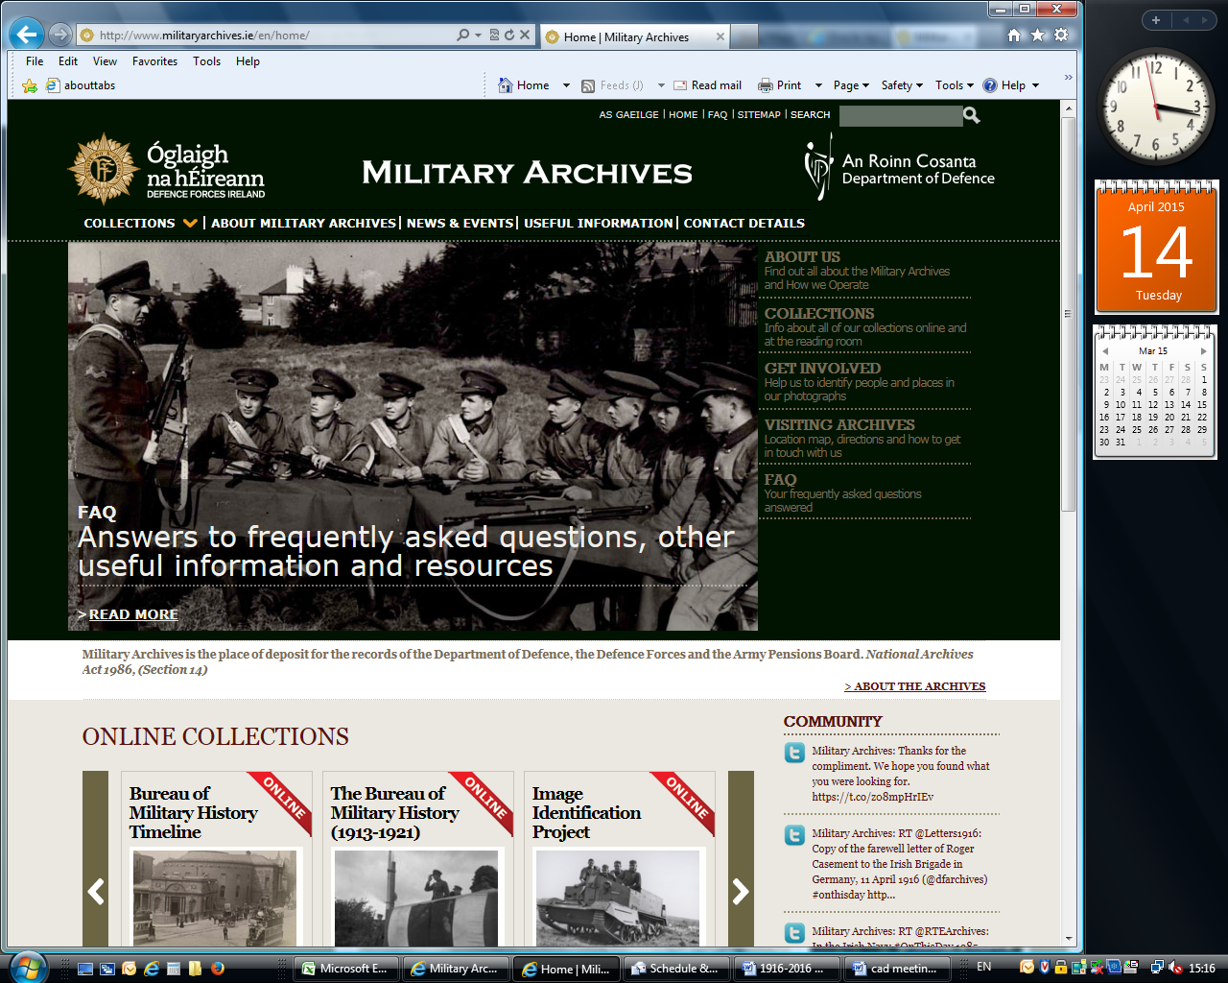

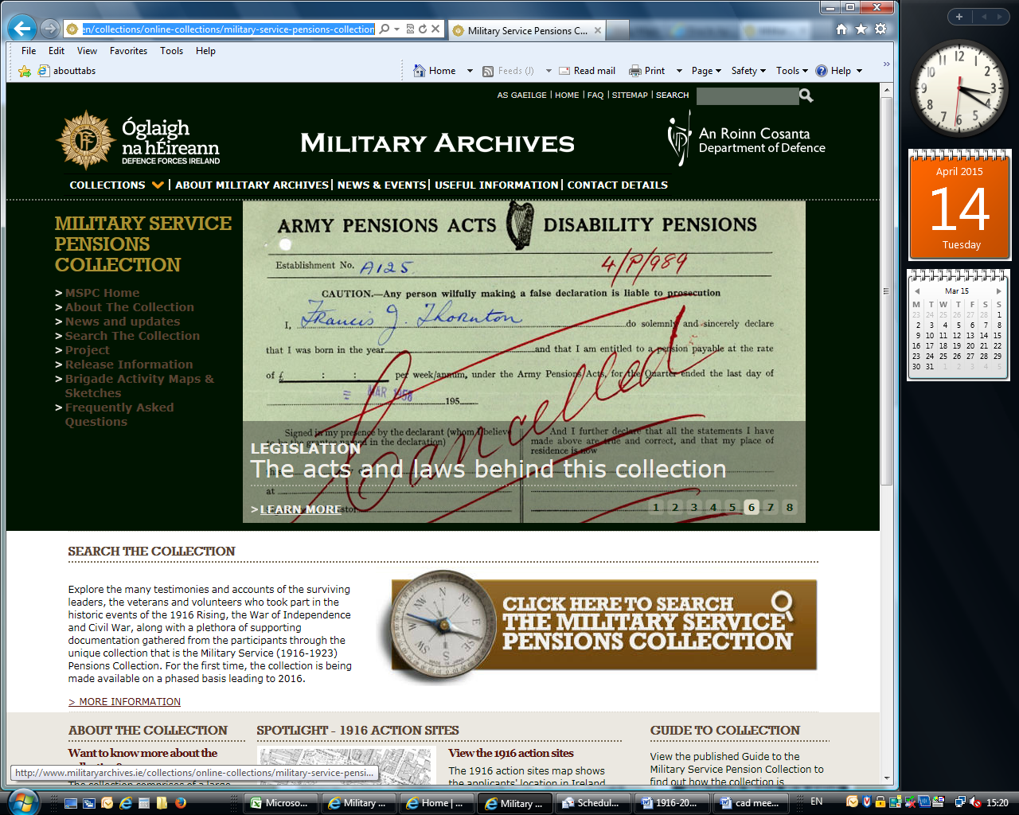

National Library of Ireland: <http://www.nli.ie/1916/1916_main.html>

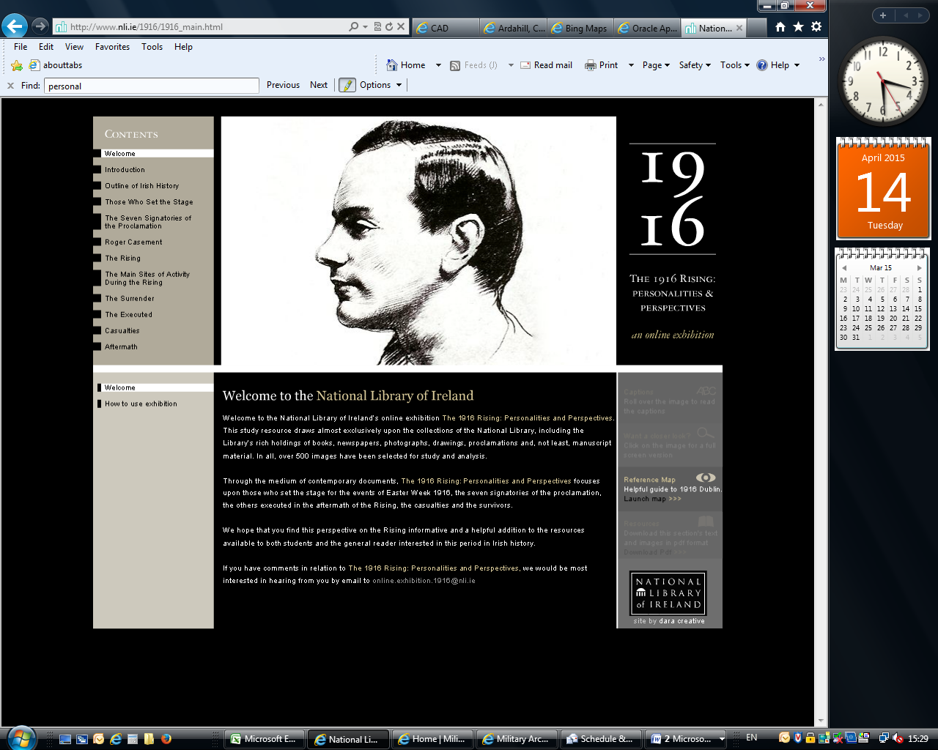

Glasnevin Cemetery Museum

<http://www.glasnevintrust.ie/>

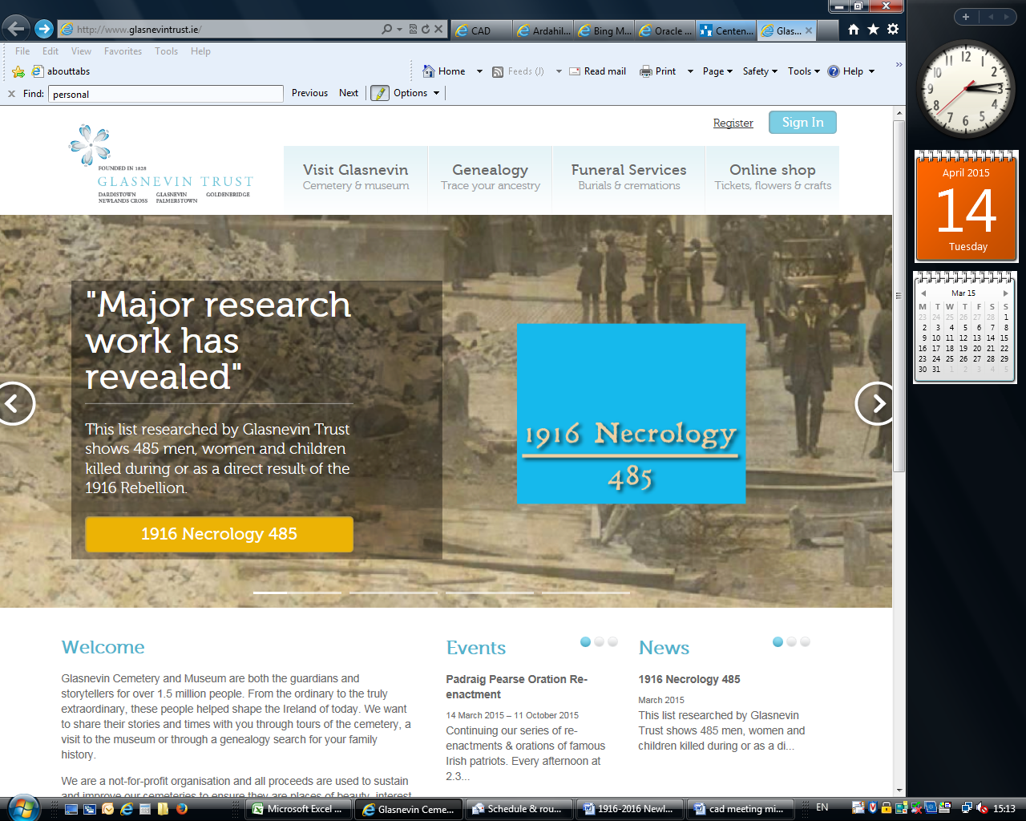

### 1916 Web Site Links

Here’s a number of web sites that may be of interest.

***March 28 - Easter Monday***

* Wreath laying ceremonies throughout the capital & state at 13:15hrs.
* Official opening of the Easter Rising Centre at the GPO.

***March 29***

Liberty Hall Ceremony

***April 2***

Children’s Day

***April 3***

Journey of Reconciliation

***April 21***

Wreath laying at Banna Strand for Roger Casement

**2015**

***August 1*** *–* ***Glasnevin*** State Commemoration of the funeral of O’Donovan Rossa.

**2016**

***January 1*** *–* ***Dublin Castle*** Opening events of the State Commemoration program.

***March 8*** *–* ***Richmond Barracks, Dublin.*** Women in the 1916 Rising Exhibition.

------------------------------------

*Full details at ireland.ie*



Page 4